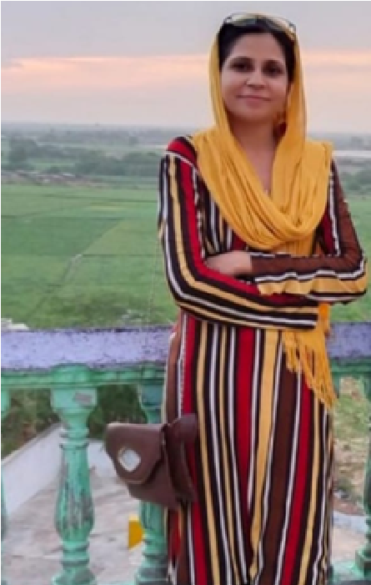

My last recent role as a Frontend Development Teacher at Tech Force Pakistan.

Position

2024

Tech Force Pakistan

+92-332-2236597

uzmahmed26.uk@gmail.com

Ho# A1-125

Sec-18A

Quetta

Town

Co-Operative

Housing

Society

Karachi-Pakistan.

**Master’s**

**International Relationship**

**Karachi University**

**Karachi University**

**Bachelor of Arts**

2017 - 2019

Graphic Designing

Web Development

Teaching

**EDUCATION**

**EXPERTISE**

**UZMA AHMED**

F r o n t e n d D e v e l o p e r &

G r a p h i c D e s i g n e r

**Experience**

Experienced Front End Web Developer with expertise in HTML/CSS, Tailwind CSS JavaScript, and TypeScript, Next Js. Proficient in developing intuitive, user-friendly websites and applications.

Professional Summary

Working Experience as a CSO in K-Electric Limited in Customer Care, New Connection Department.

Work Experience

2008 - 2017

K-Electric Limited

**Reference**

English

Urdu

**LANGUAGE**

Textile Designing

**References available upon request**

**Student at GIAIC**

**exploring web metaverse 3.0, artificial**

**intelligence at Governor House Karachi**

**GIAIC**